**Order Enty NSE- Cash**

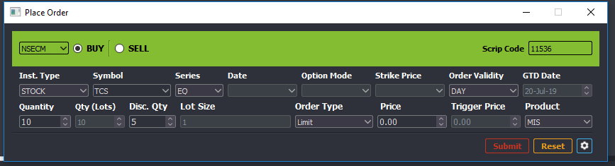

Modify (Qty)

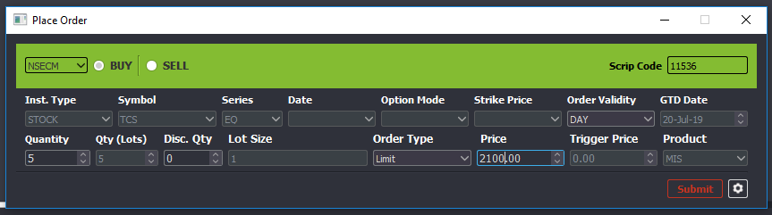

Order book after Modification (Qty)

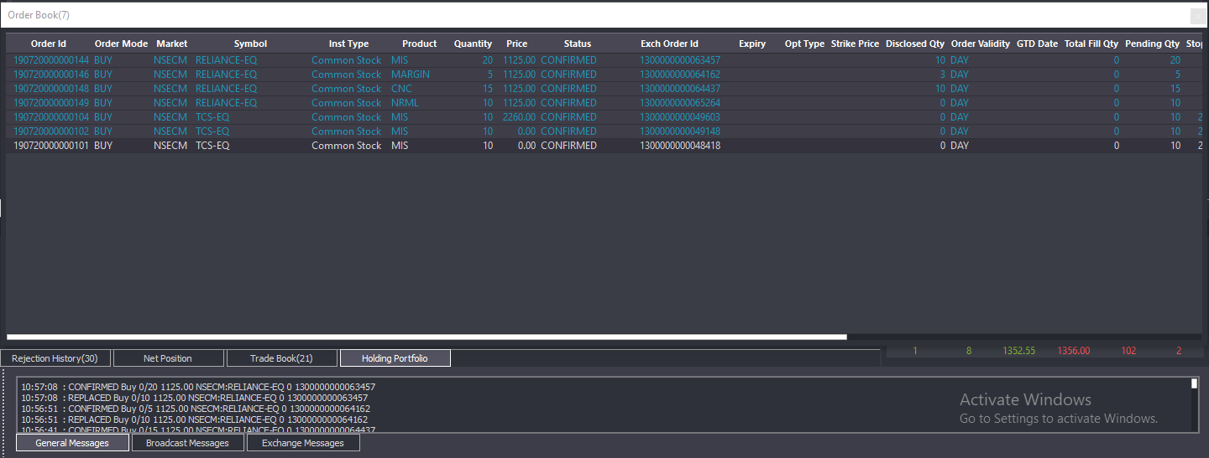

Modify (Price)

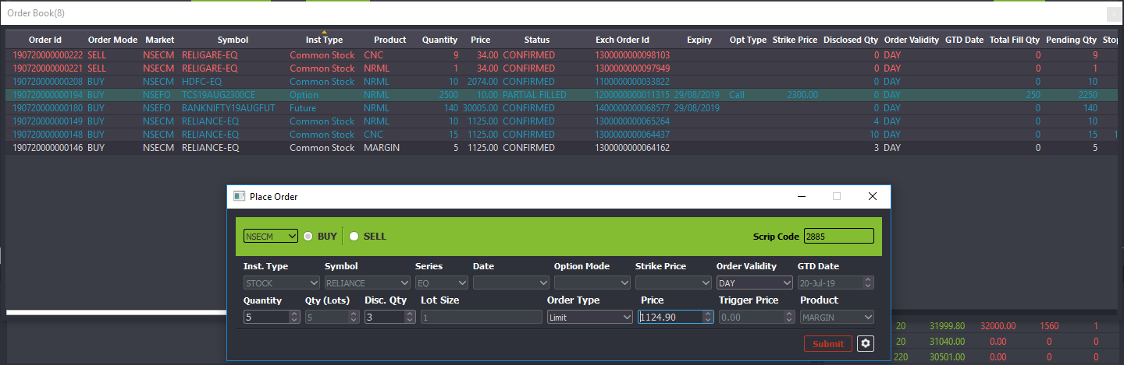

Order book after modification

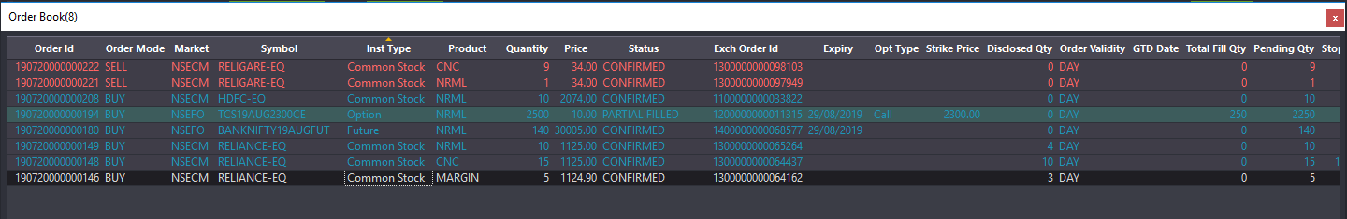

Modify (DQ)

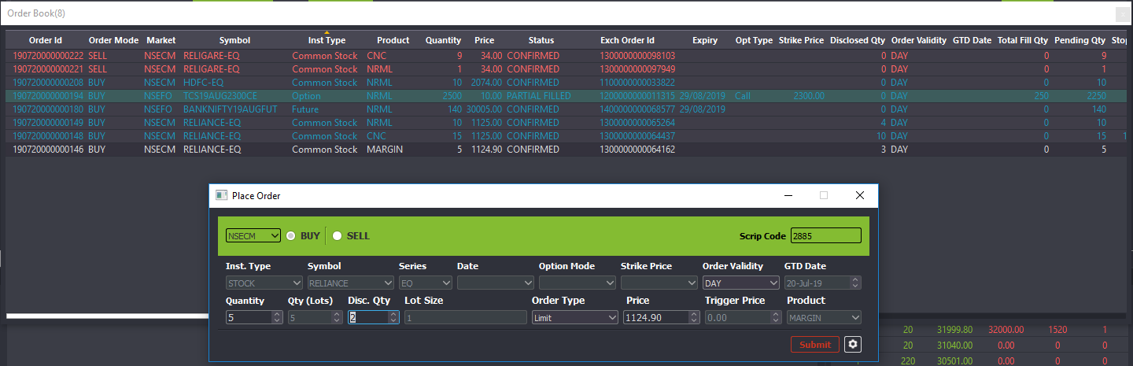

Order Book after Modification

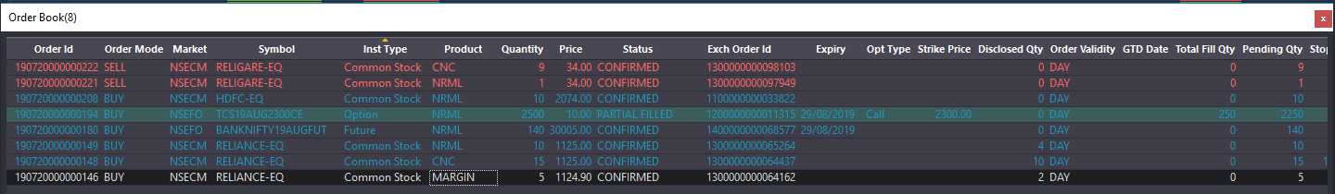

Modify Limit to SL-Limit

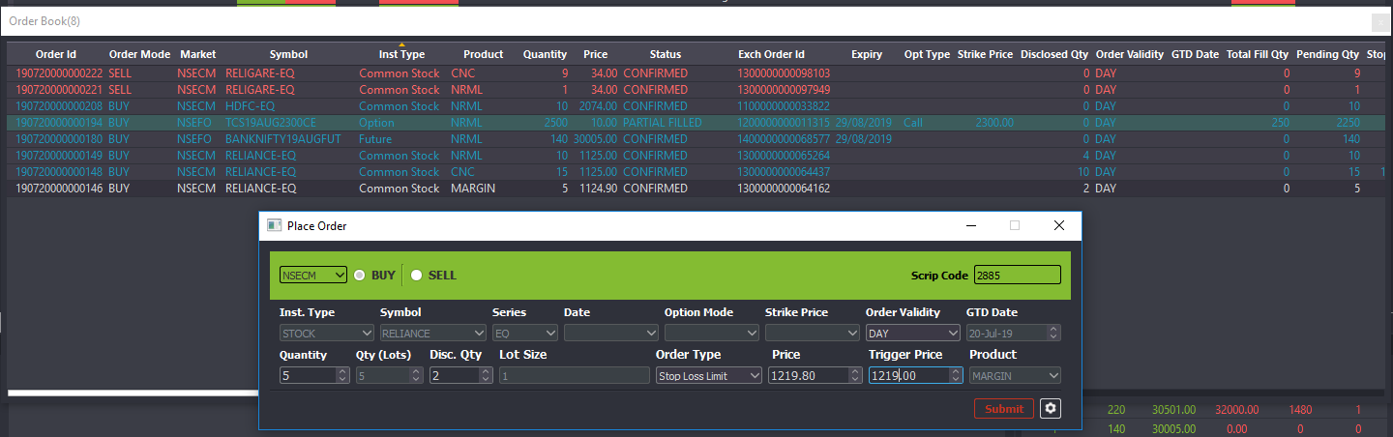

Order book after modification

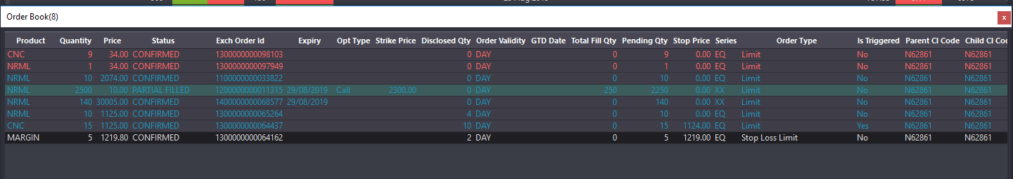

Modify SL-Limit to SL-M

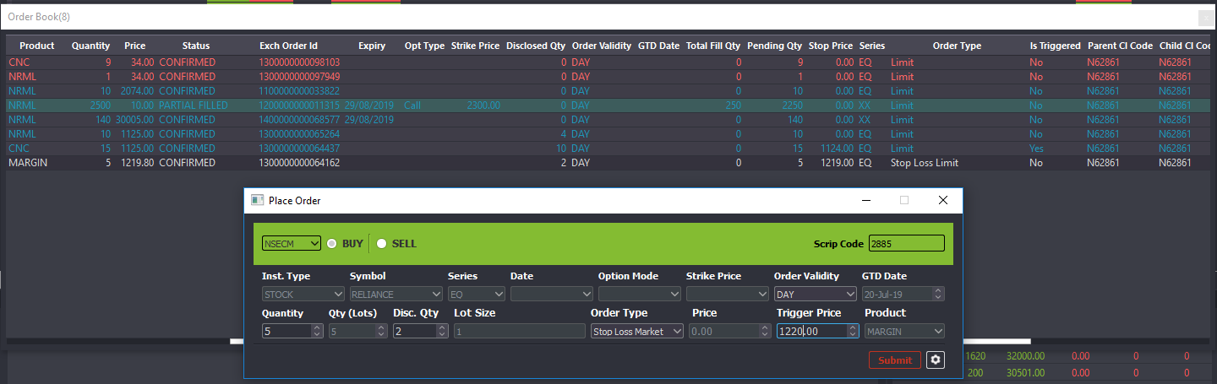

Order book after modification:

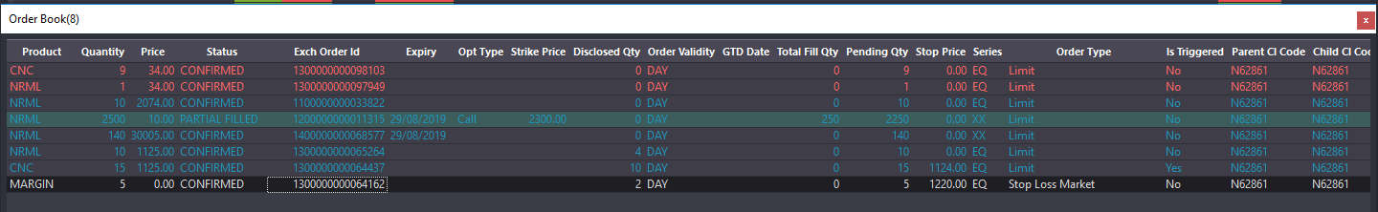

Cancel

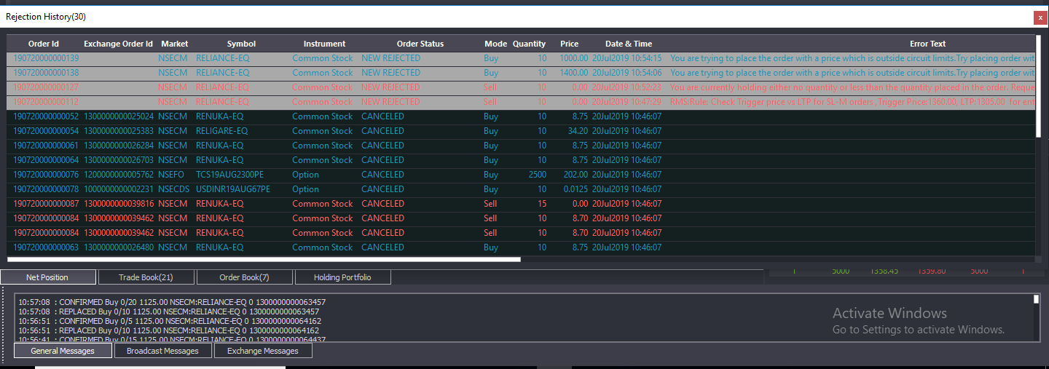

Order Book

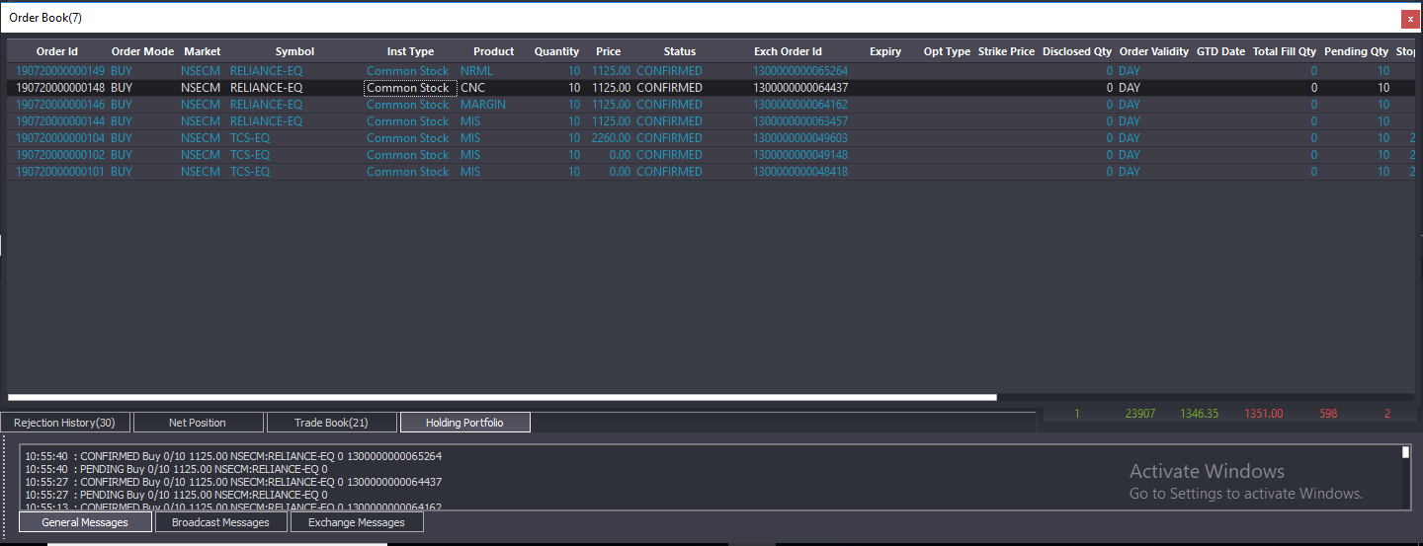

Trade Book

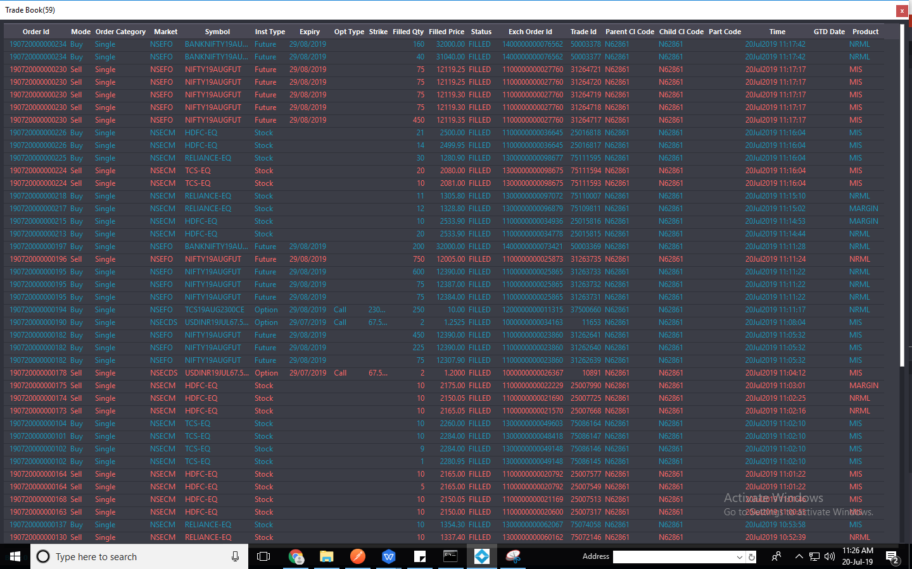

Net Position

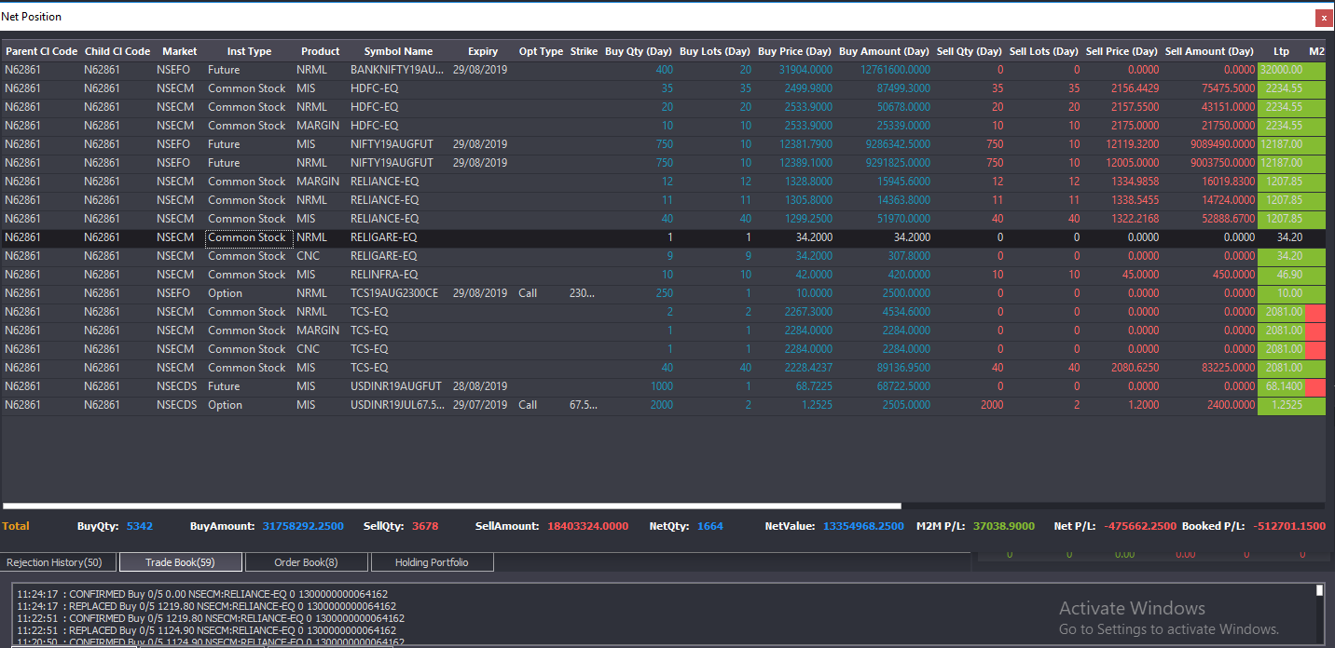

Position Conversion

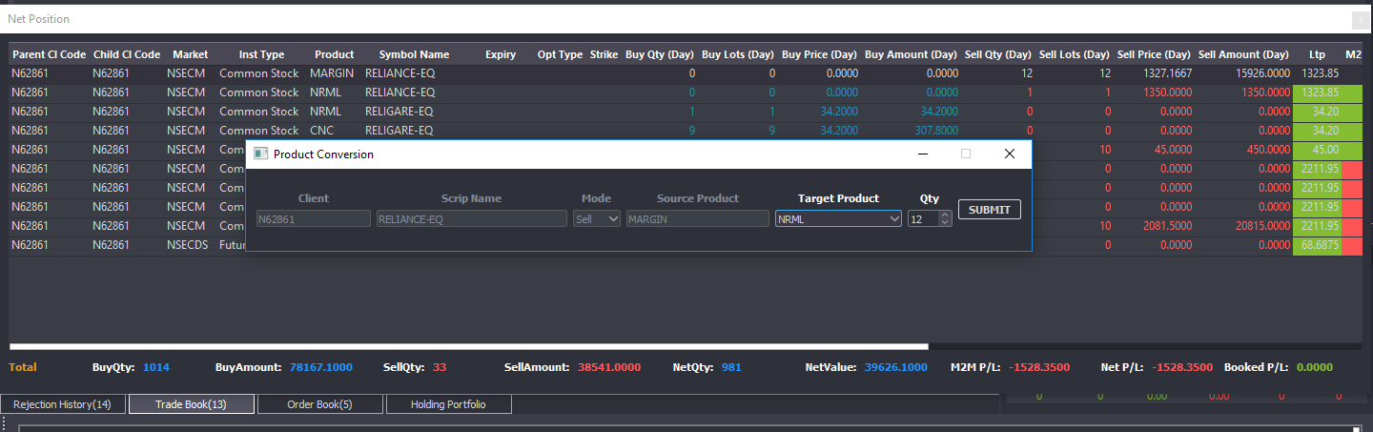

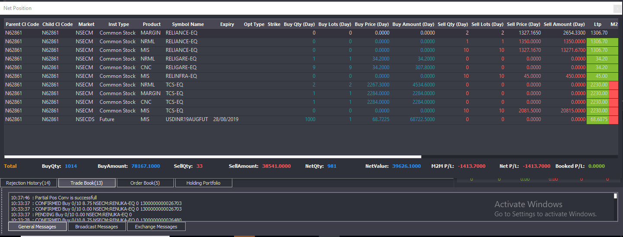

**Order Placement NSE - FO**

**Order Entry**

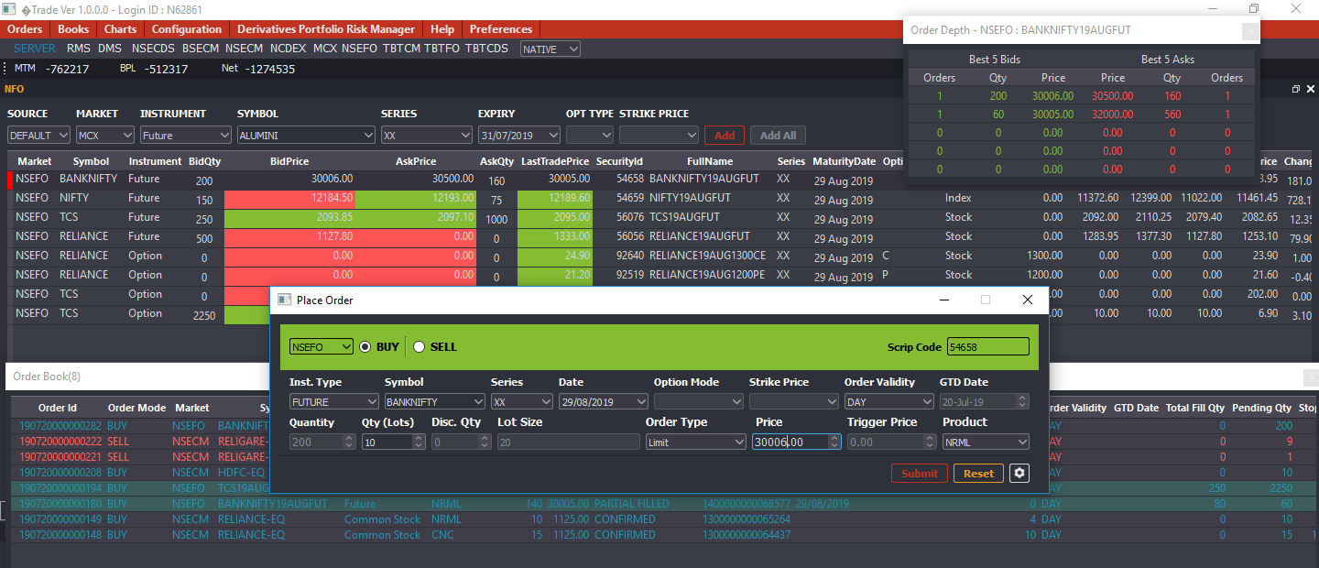

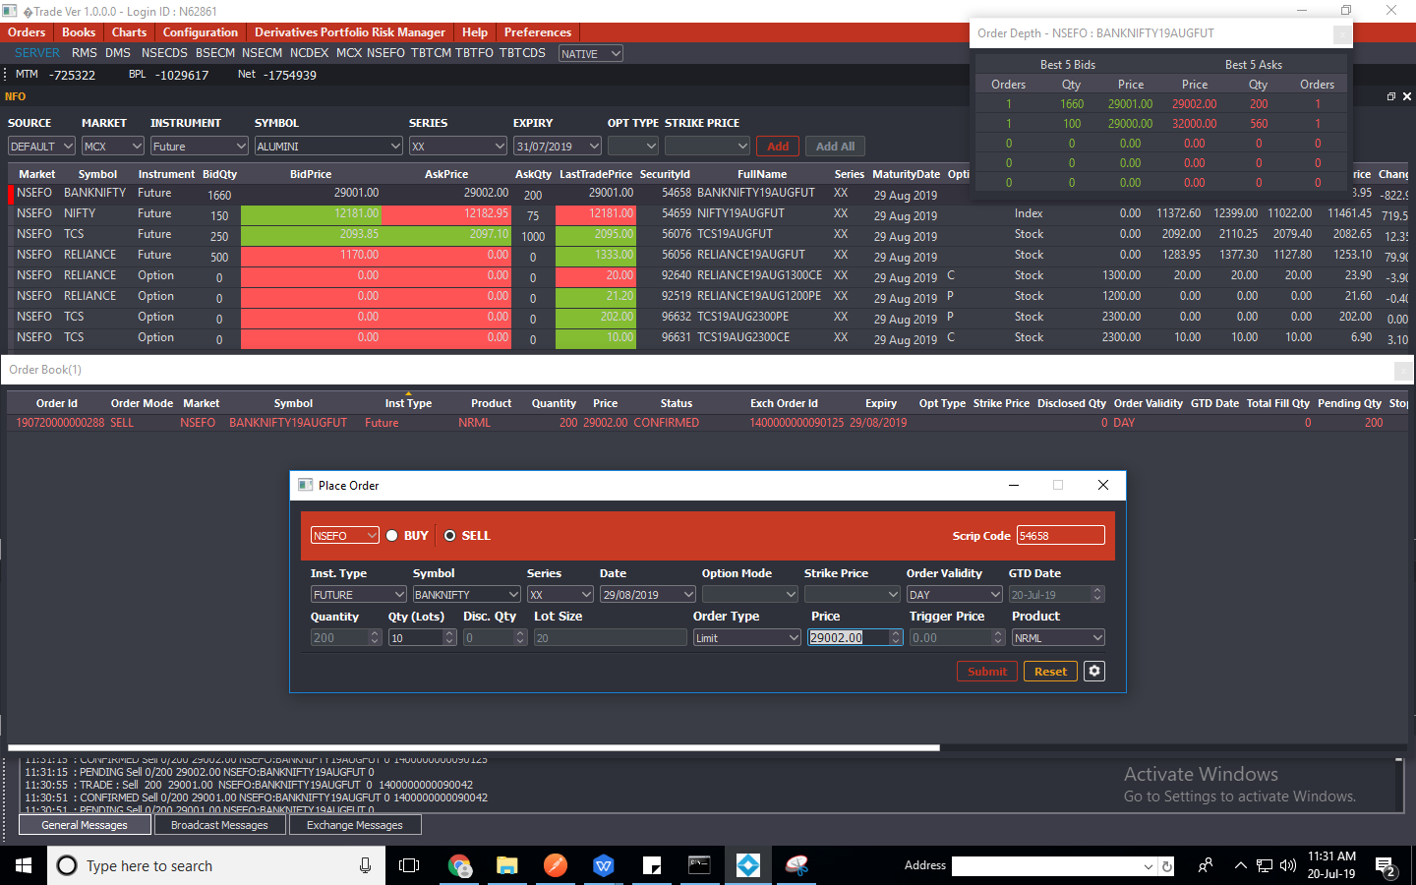

Order Qty Modification

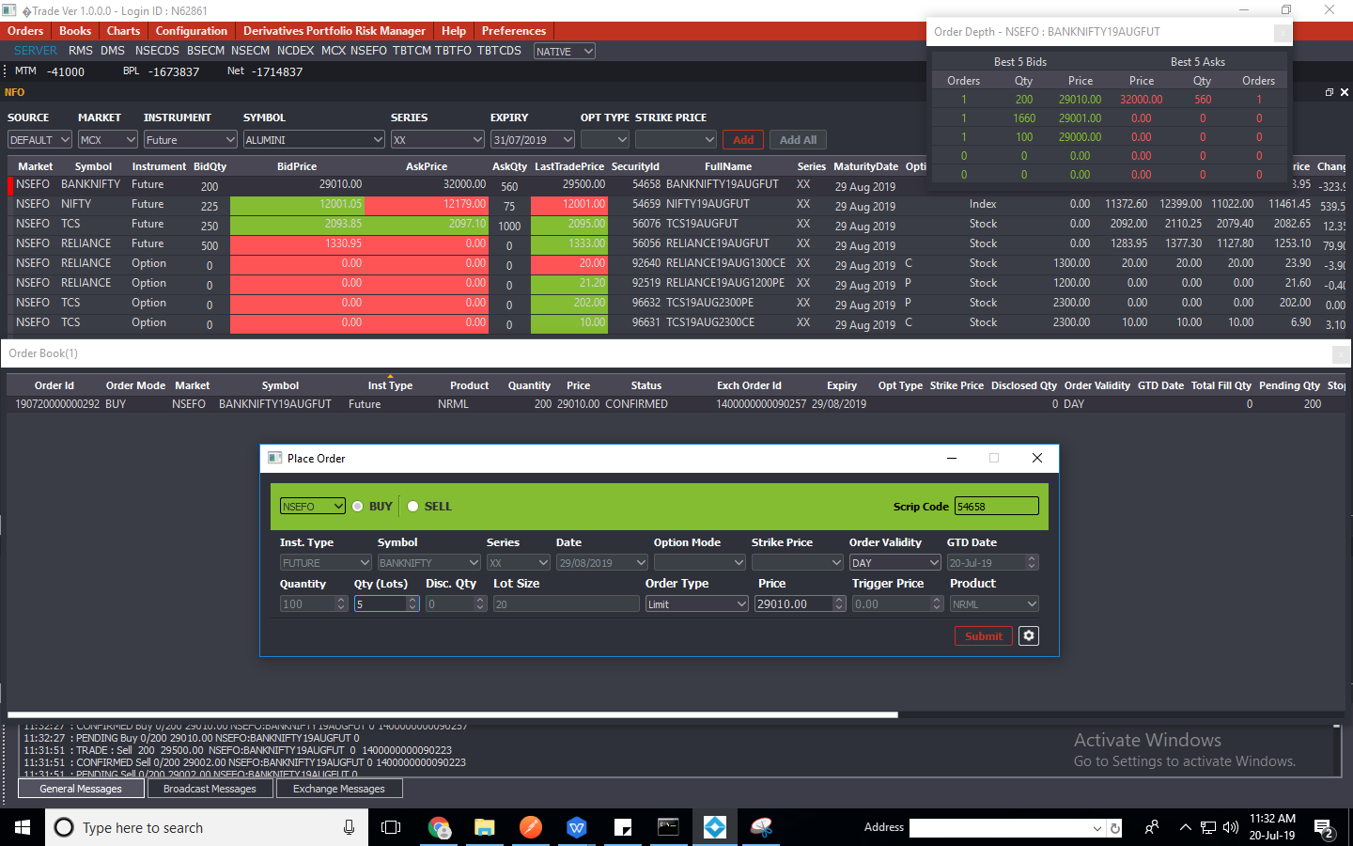

Order Book After Modification

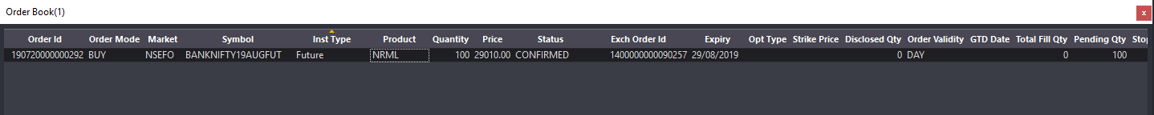

Order Price Modification

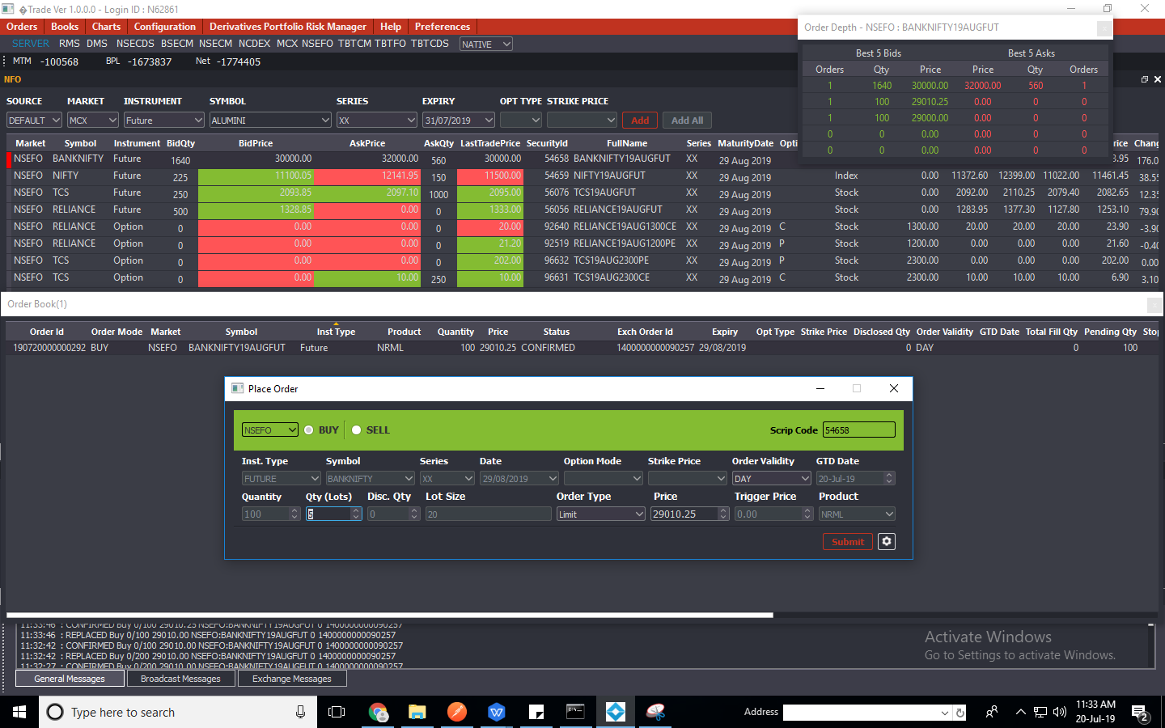

Order Book after Modification



Modify Order from Limit to Market

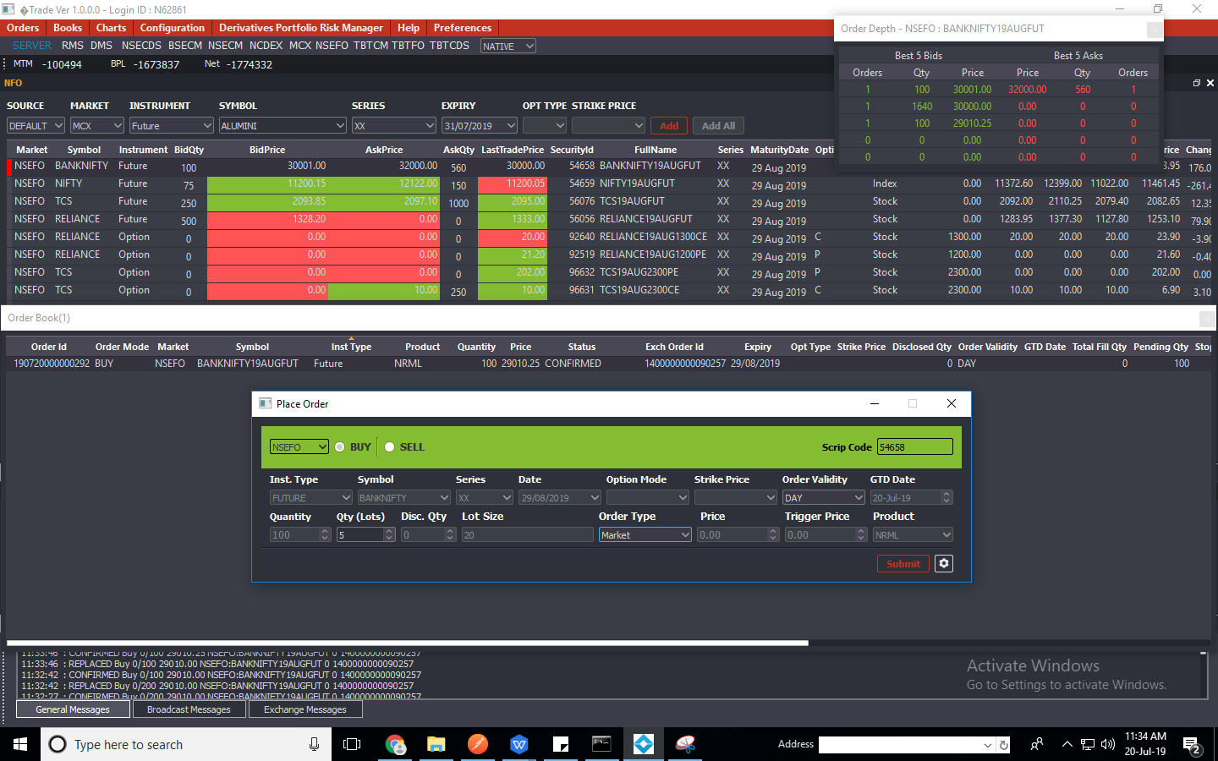

Order book after order modification

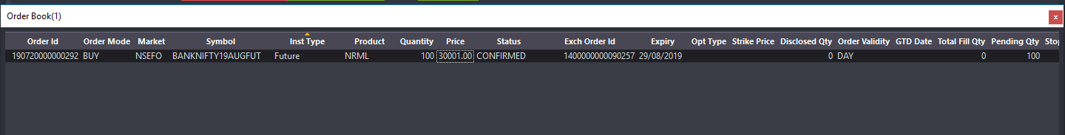

Partial Order Modification

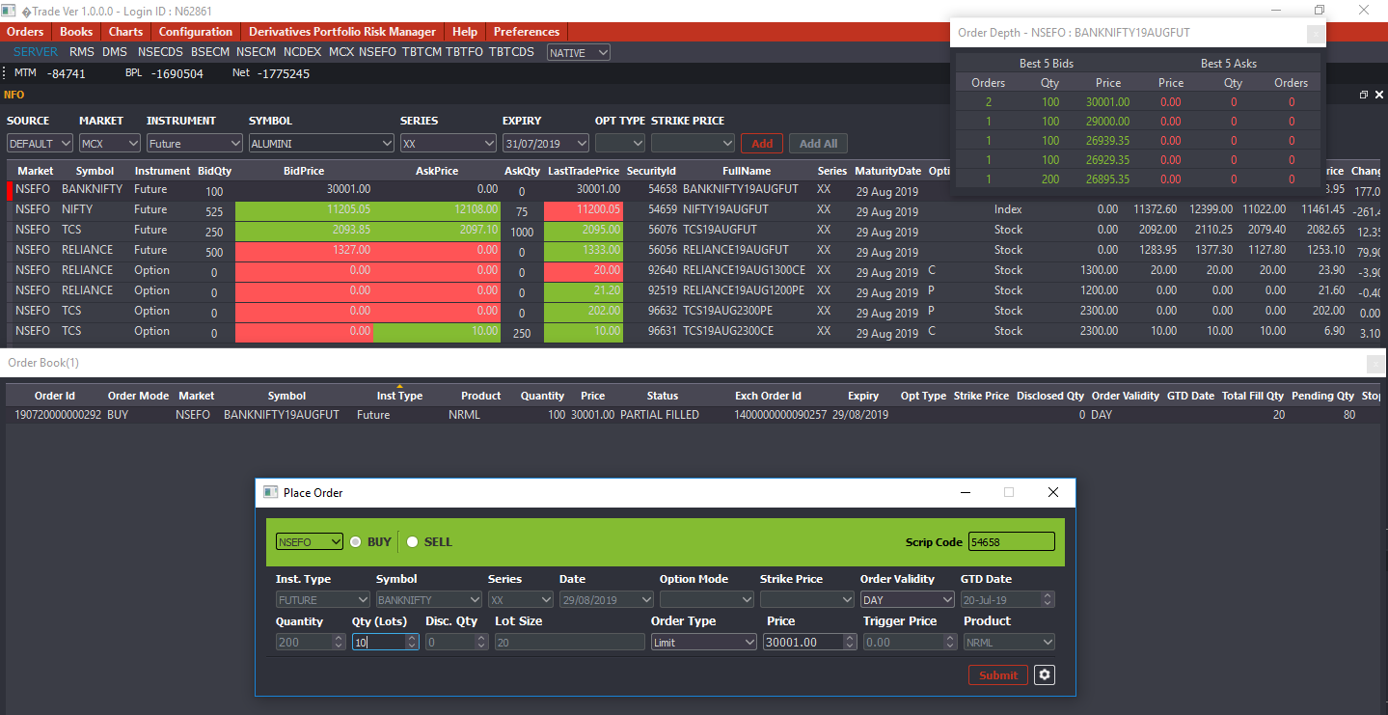

Order book after modification

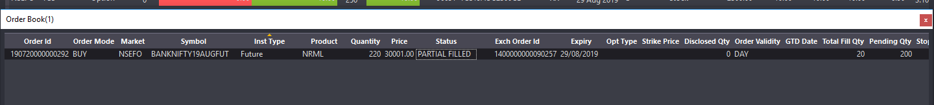

Modify order limit to SL-Limit

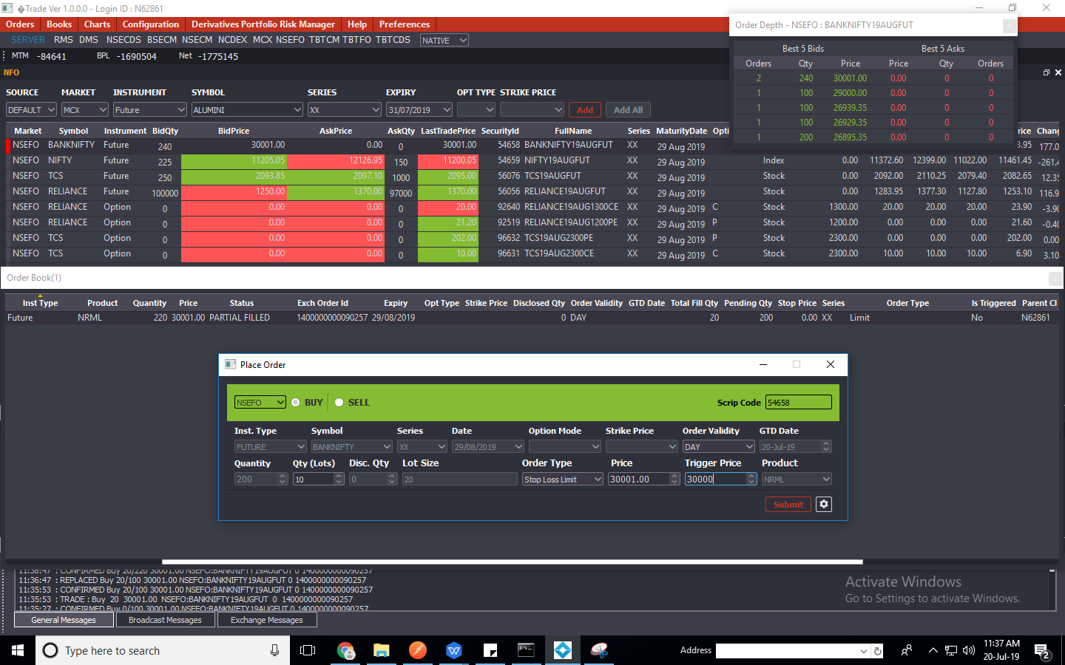

Order book after modification

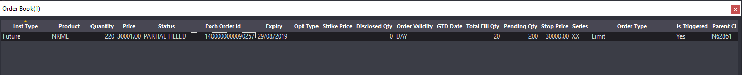

Square off order :

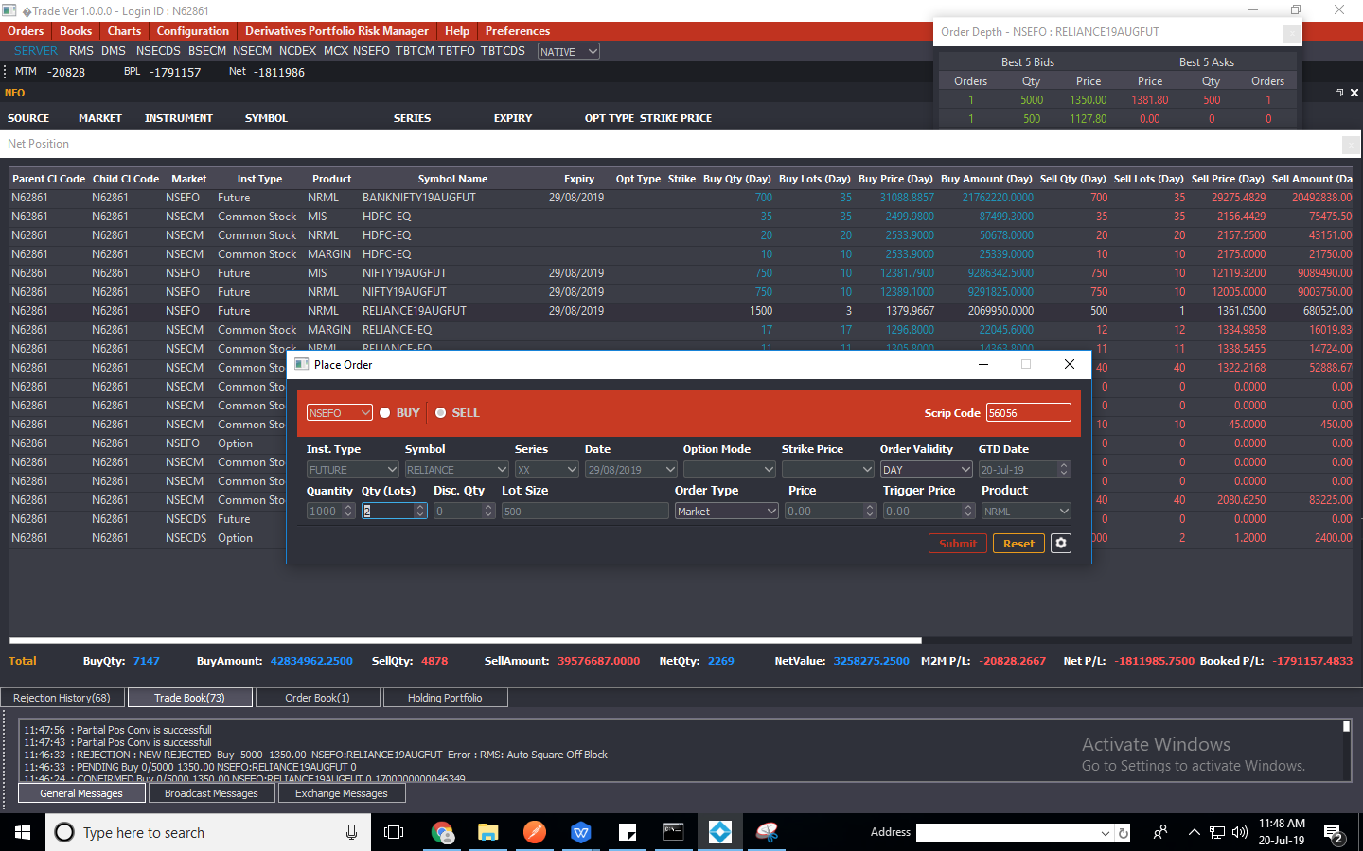

Net Position after Sqaure off

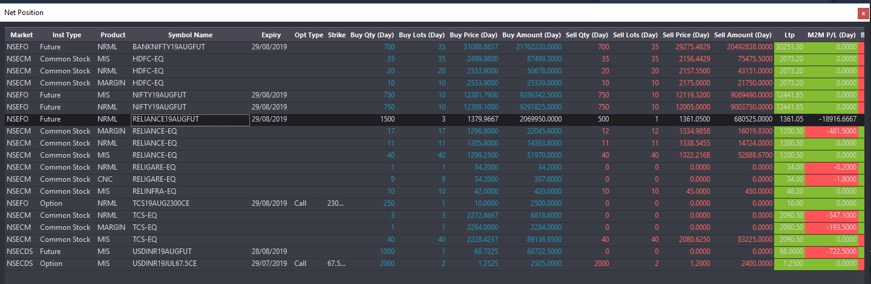

Traded Order

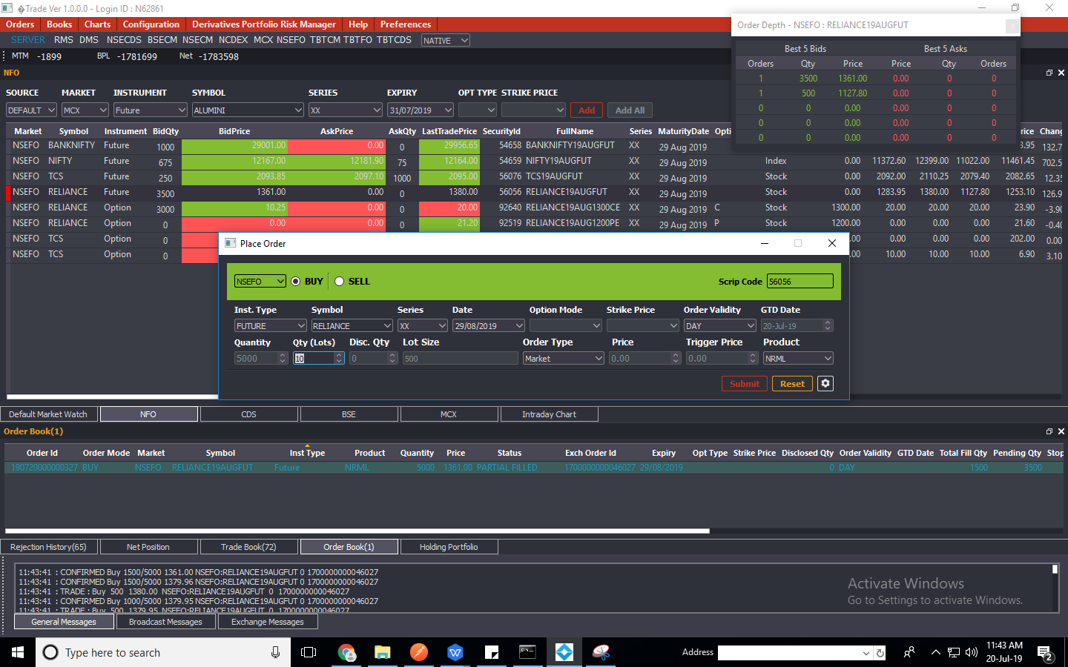

Position Conversion

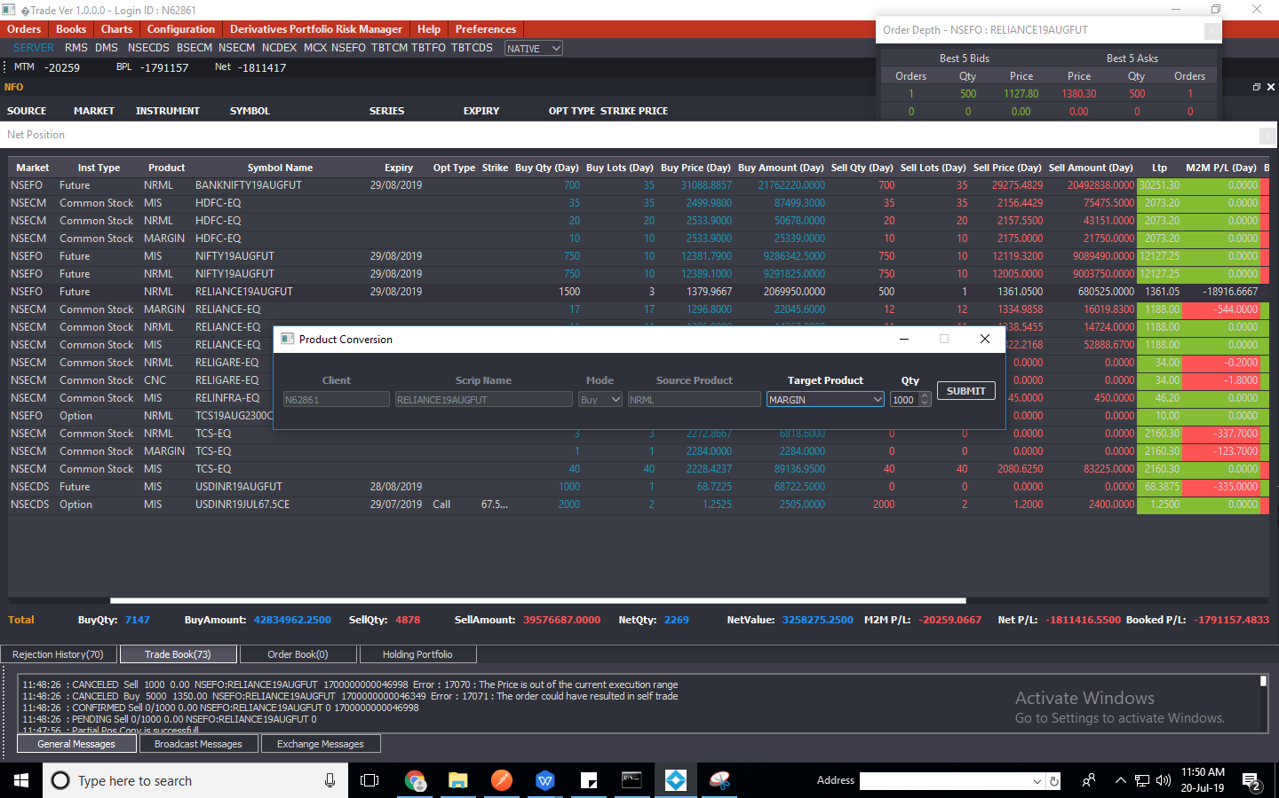

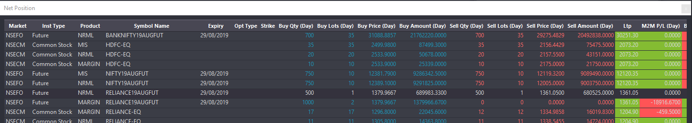

SL-Limit Order

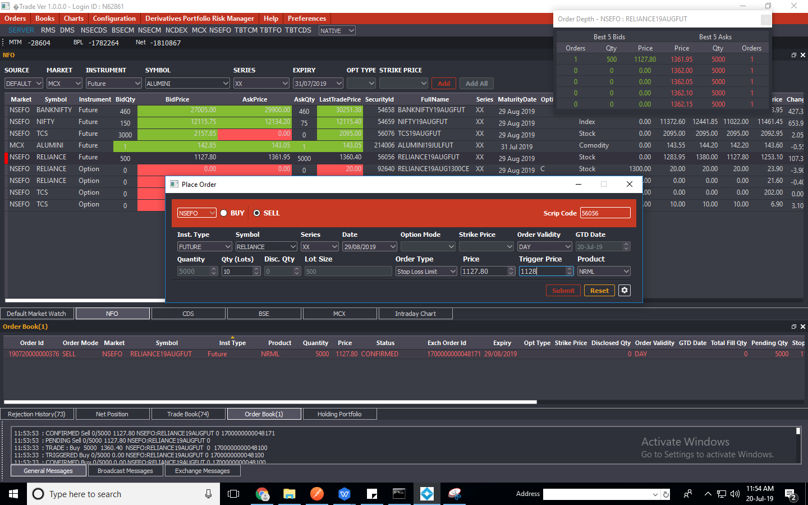

Order book

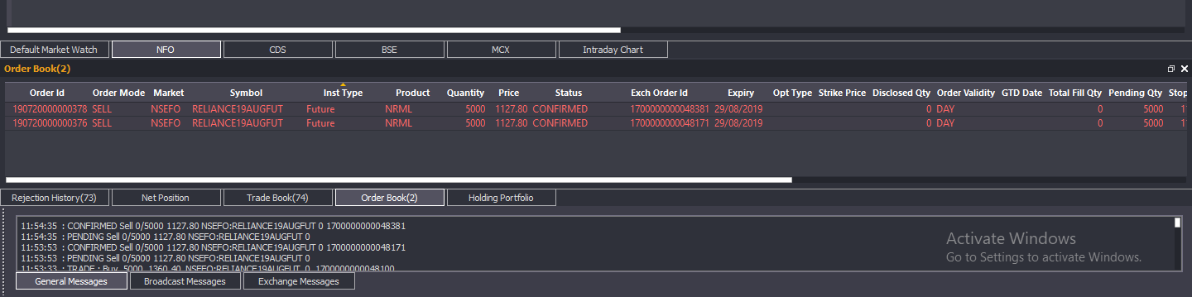

Redis

